Procedure for collection of pets upon arrival into Singapore Changi Airport
- Ensure Air Way Bill, export/import permits, certificate of health, etc are printed.

- Upon arrival into Singapore, head to the Changi Airfreight Centre Pass Office. Here you will need to have the hard copy documents (they may not accept email or soft copy)
You will also need to hand over your passport, which they will hold onto until you return the pass they provide.
Location: https://goo.gl/maps/PwccT8ScBmF2.
  - Please note: Grab/Uber drivers cannot take you past the Pass Office. You will need a taxi driver with a 'Vocation Licence', or alternatively you can get the bus from the pass office.
- Once you have received the pass, drive through the checkpoint.
  - You will be required to show the security officer your pass.
- Head to SATS Airfreight Terminal 6, Core N, Level 1M, Airline Road (see picture below). This is the large building on the right almost as soon as you go through the checkpoint. It is directly opposite the first bus stop.
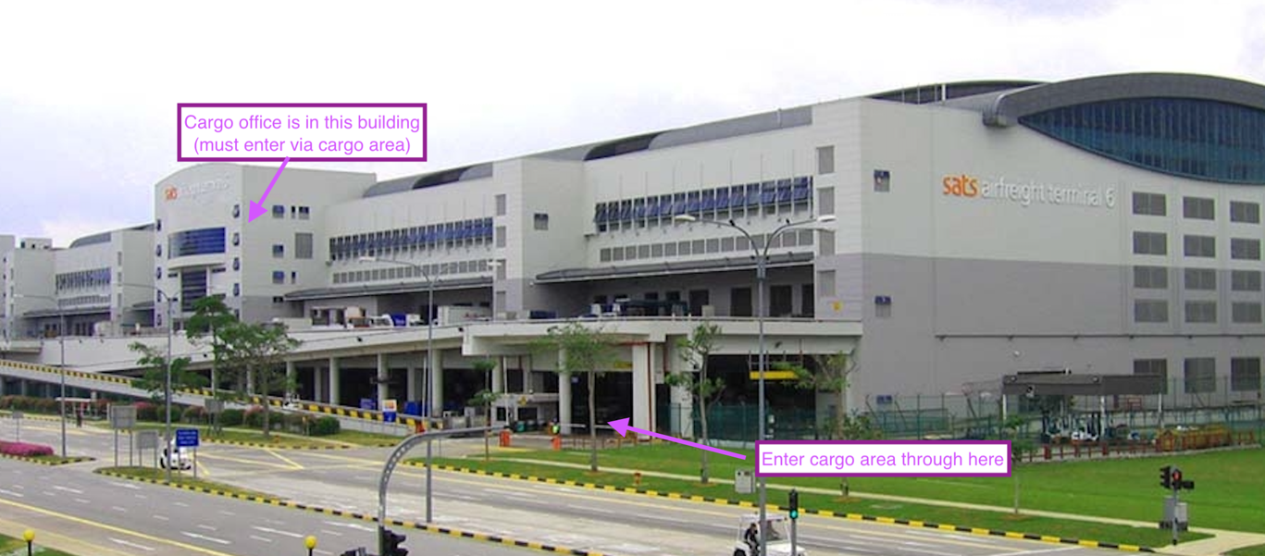
Location: https://goo.gl/maps/1vpTxkz5pbU2

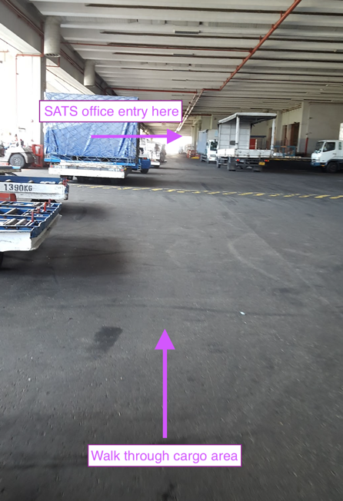
- You will have to walk through an undercover cargo area (see photo on right), where you will find an office to the right about 50m down the cargo area.
- Once you are there, take the elevator to Level 1M. At the counter, hand over the import licence/airway bill documents, and produce some ID (drivers licence OK - keep in mind you will not have the ID you left at the pass office).
- Once they have sighted these forms, they will give you back the original documents from the flight.
- The clerk will then direct you to take the elevator to another level, where you go to the payment counter. You will then need to provide the documentation again, and pay $155 via NETS or credit card (they don't accept cash).
- Once this is done, they will provide you with a receipt which you will need to collect your animal/s.
- Once this is complete, drive to the Changi Animal and Plant Quarantine Station (CAPQ)
Location: Airport Cargo Road, Gate C7 - https://goo.gl/maps/YUrzeAkdV1F2
  - To get there, continue driving straight (past the SATS building you were in on the right), until you get to a bend in the road which goes to the left. Then there is a gate which says AVA. Park in the carpark there and enter the building.
*Please note that these buildings are in a restricted area, separate to the main airport. You will require transport to get there and should allow at least 30 minutes to travel from Changi to the cargo area.

